**FINAL LOGIN PAGE AND PAYMENT DONE BY USER:**

**SELECTING PLACE FOR JOURNEY:**

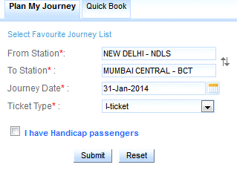

**TRAIN STATIONS:**

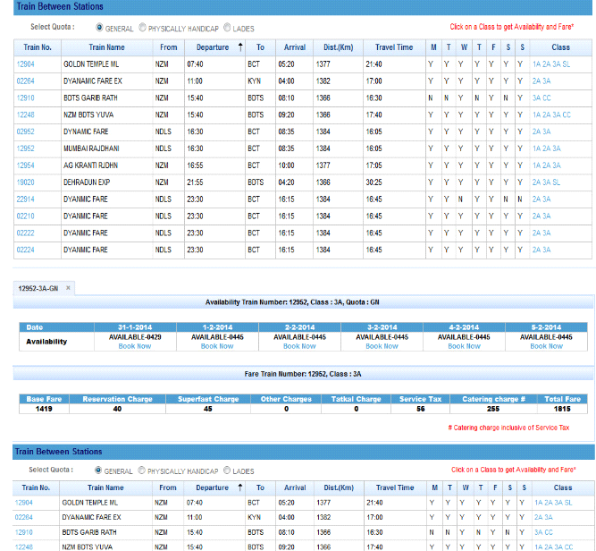

**PASSENGER DETAILS IN DATABASE BY BOOKING THE TICKET:**

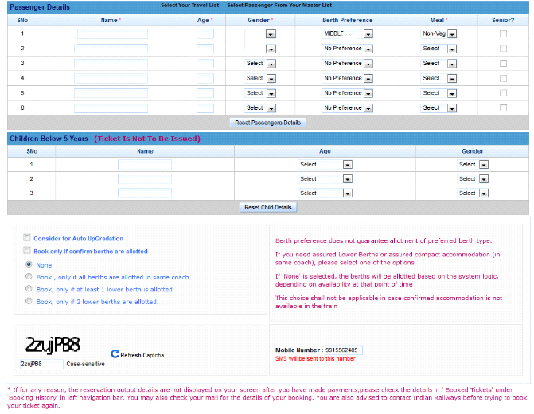

**PAYMENT OPTION:**

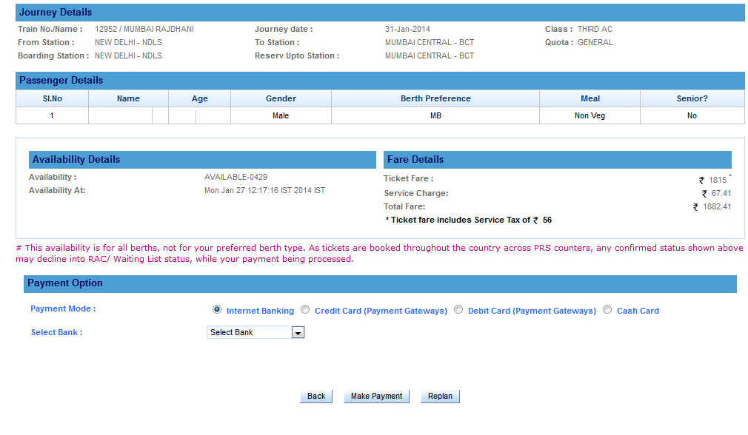

**DETAILS OF A PASSENGER:**

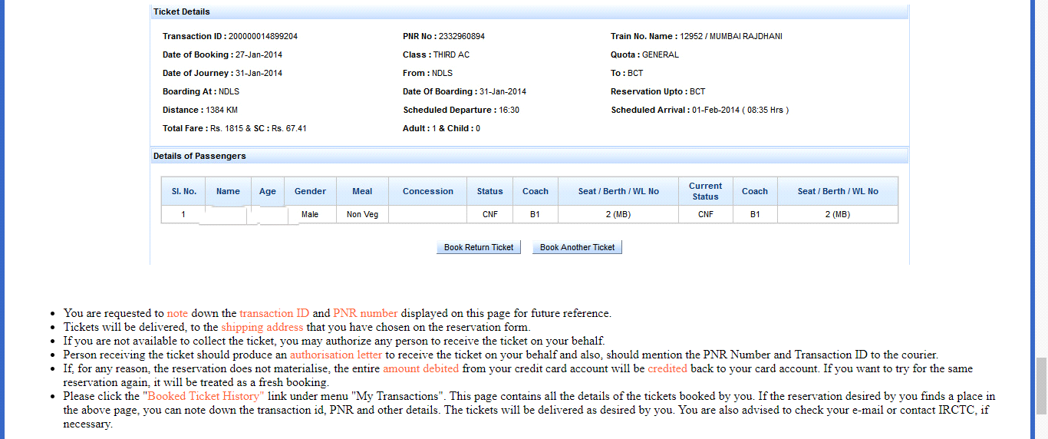

**BOOKED TICKET HISTORY:**

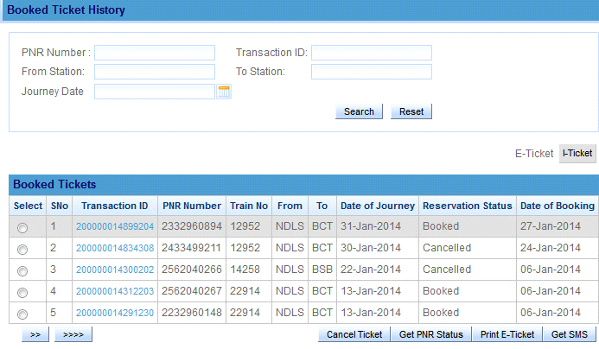

TEAM ID:PNT2022TMID14986